# **Appendix- A: User Interface Design**

## **UI Design:**

User Interface is the outline for a system or product, for example, the look of an application, without breaking a sweat of utilization for the client. In short design patterns are solution to repeating issues. By augmentation, UI configuration designs are answer for normal UI issues. It configures more often than not alludes to the plan of graphical UIs—however can likewise refer to others, for example, regular and voice UIs.

UI Design interiors around envisioning what clients may need to do and ensuring that the interface has components that are reliable for access, comprehend, and use to encourage those activities. UI unites ideas from association outline, visual plan, and data engineering. Some elements of the Interface –

**Input Controls** – Buttons, text field, radio buttons, checkboxes, date field

**Navigational Modules** – Icons, sidebar, tags, slider, search box

**Informational Elements** – Message boxes, Notification bar

**Containers – Accordion**

<https://www.usability.gov/what-and-why/user-interface-design.html>

## **User Interface Design Process:**

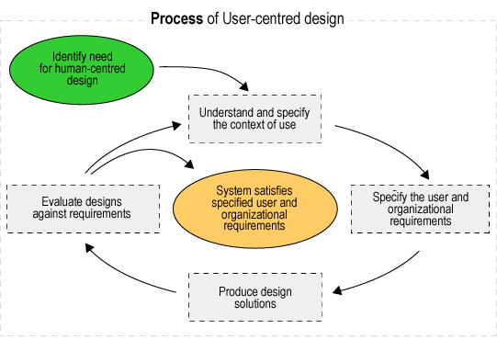 User Interface comprises some processes. This process must have to follow a designer to draw the interface of ant system. In this section those processes are represented –

**Figure 10: Process of UI Design**

<http://ui-designer.net/interface_design.htm>

## **User Interface of system:**

Proposed system User Interface Design is given below –

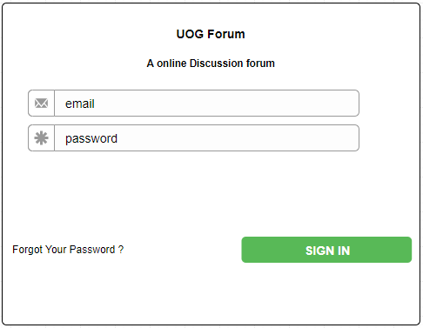

**Figure 11: Login Form**

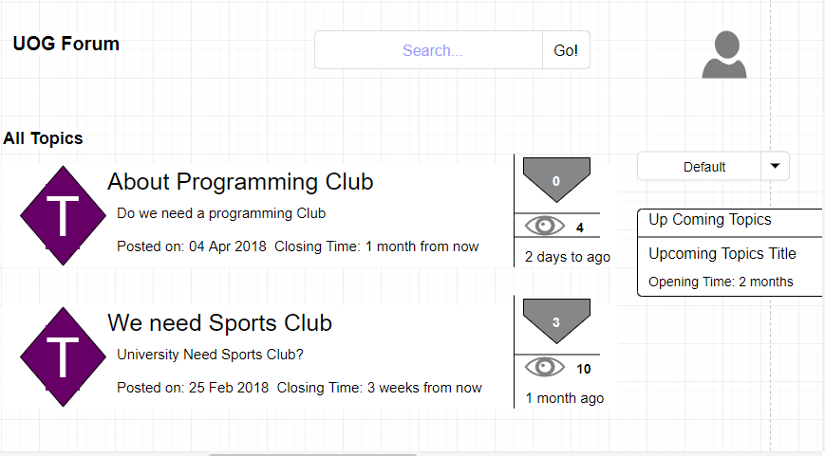

**Figure 12: User Interface of UOG Forum**

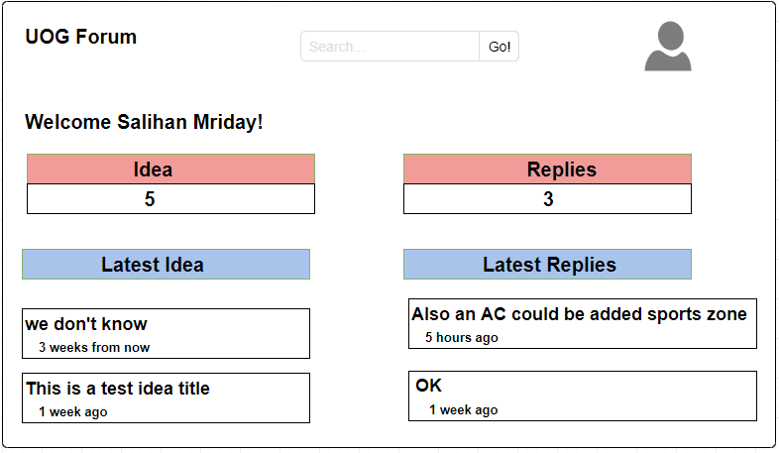

**Figure 13: Student Dashboard**

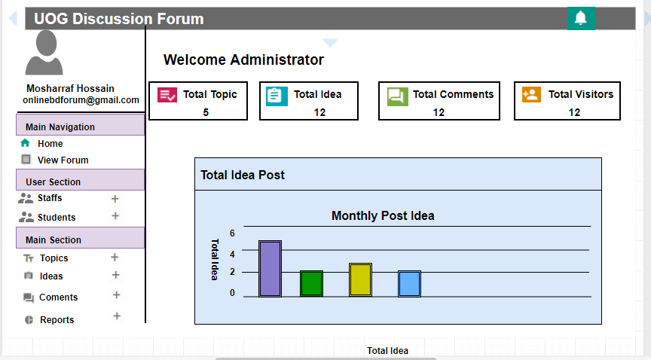

**Figure 14: Admin Dashboard**

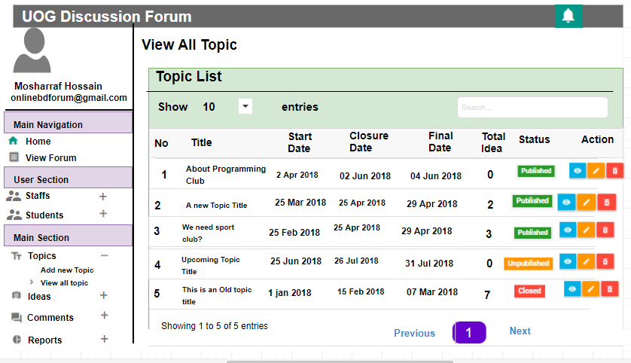

**Figure 15: View Topic List**

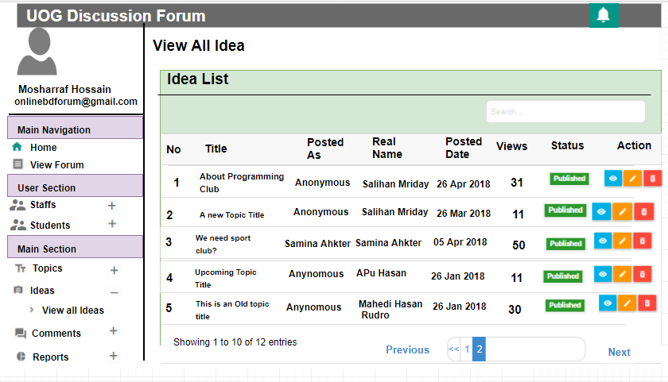

**Figure 16: View Idea List**

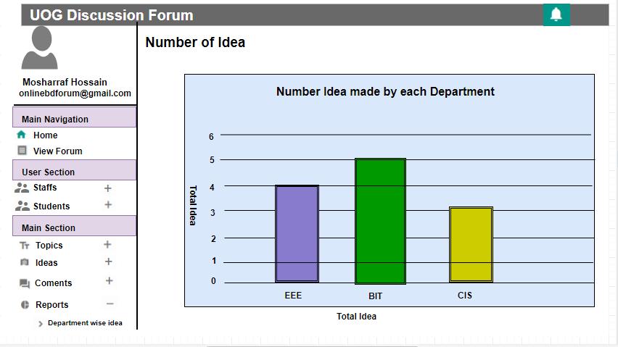

**Figure 17: View Chart of all the posted idea by Department**